Owen Lindsey

CST-345

Professor Sluiter

11/19/2023

Activity 6

Part 1: Atlas dashboard

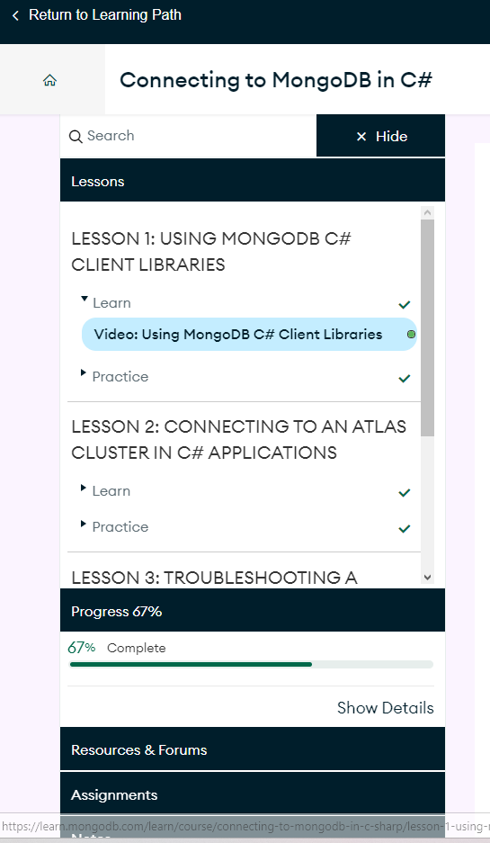

Part 2: Application

This screenshot shows that albums load in, and the art comes up when the album is clicked.

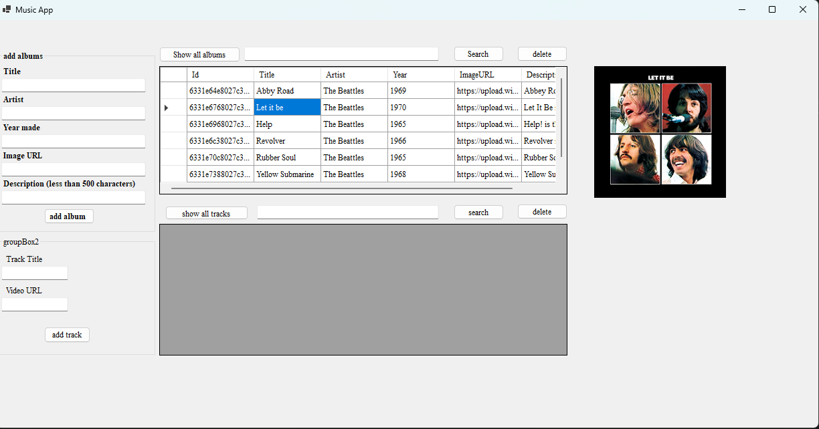

This screenshot shows that albums can be added and that the album art displays when clicked.

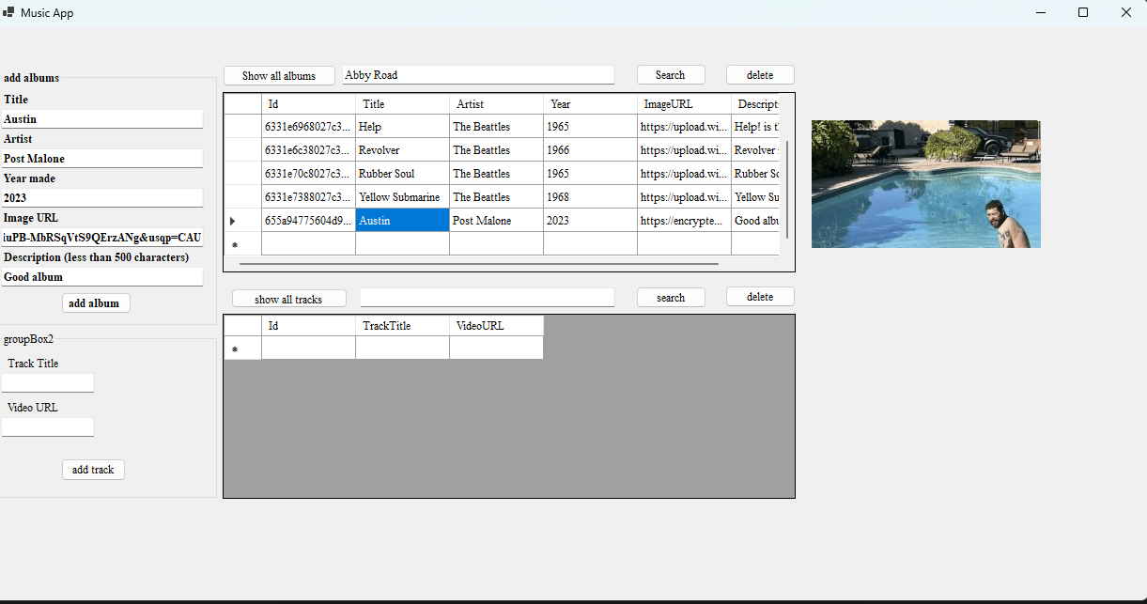

This screenshot displays the ability to search for albums in our database. 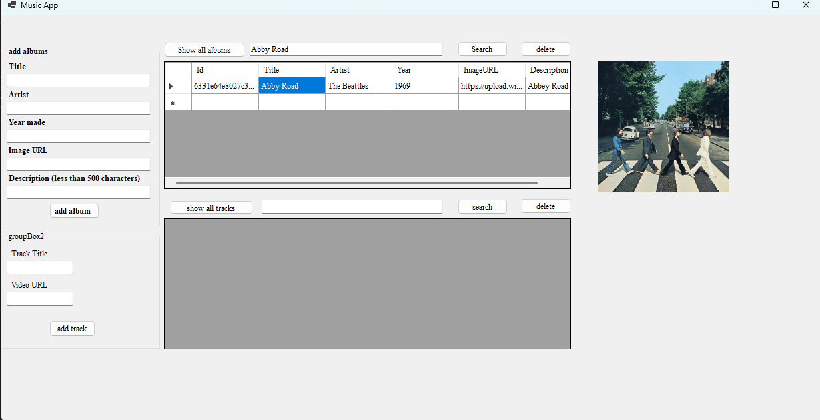

This screenshot shows that we have deleted the Post Malone album from our database. This screenshot shows that if we search for the song yello3 in the album yellow submarine we can isolate that track.

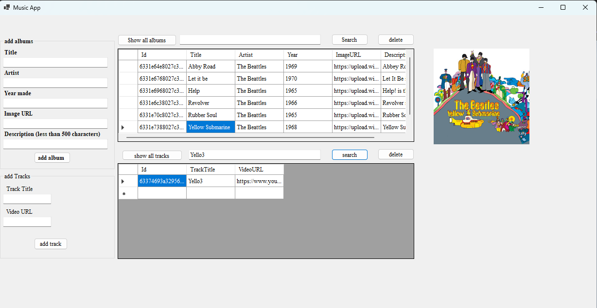

Then we can add a track. We have added the song “Sea of Holes" to the album yellow submarine.

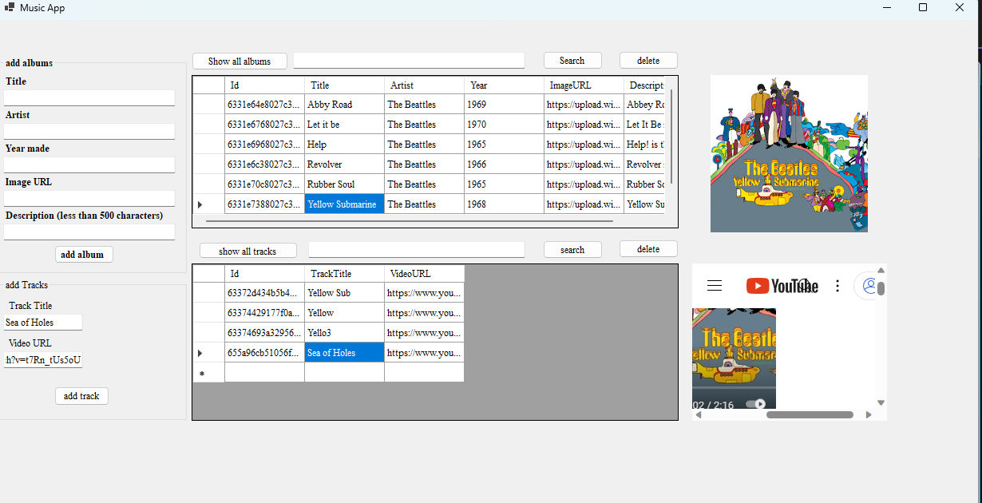

Then we can delete that track.

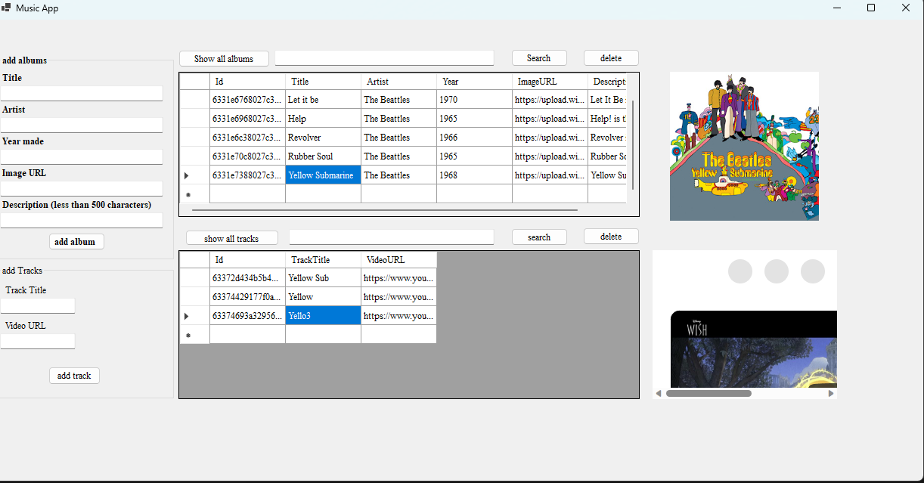

Part 3: Write up

This assignment showed me how to configure a Mongo database through the lessons in MongoDB University. Later in the lesson, we learned how to take our SQL music application and applied that lesson to use a Mongo database instead of a SQL database. Learning NoSql is important as we will see companies that use a variety of database management systems and Mongo is an extremely popular choice for NoSql database management.